# Media Analysis - ChatGPT is the ‘Netscape moment’ for artificial intelligence’ _ Arab News

## Short Summary

The article is about how ChatGPT represents a transformative moment for artificial intelligence similar to Netscape s impact on the World Wide Web, highlighting its capabilities, current limitations, potential future developments, and strategic importance for economic productivity and innovation, particularly in Saudi Arabia.

## Summary

- ChatGPT represents a significant moment for artificial intelligence similar to Netscape's impact on the World Wide Web, offering a rich conversational interface that has captured public interest.  
- It is built on Large Language Models (LLMs) trained using unsupervised learning on vast text corpuses, enabling tasks like question answering and content generation without explicit teaching of relationships between words.  
- Despite their capabilities, these models have limitations: they lack common sense, reasoning skills, and can generate plausible yet incorrect information due to understanding only language statistics.  
- As AI technology evolves, future systems will require augmentation with human-like attributes such as ethics and common sense to address challenges like misinformation, while foundation models offer new platforms for application development.

## Question 1

The text frames the public discussion around ChatGPT using several key metaphors:  
  
1. **"Netscape moment for artificial intelligence":** This metaphor compares the impact of ChatGPT on AI to how Netscape popularized the World Wide Web, suggesting a significant and transformative effect.  
  
2. **"Autocomplete on steroids":** This describes LLMs (Large Language Models) as an advanced version of the predictive text feature found in many digital interfaces, emphasizing their capability to generate human-like text based on statistical patterns.  
  
3. **"Hallucinations":** The term is used metaphorically to describe instances where AI generates plausible but incorrect or misleading content, highlighting a critical limitation of current models.  
  
4. **"Foundation models":** This metaphor likens the development of LLMs and similar technologies to foundational platforms like web, mobile, and social media, suggesting they will serve as bases for new applications and innovations.  
  
5. **"A general-purpose technology":** This metaphor frames these AI models as versatile tools that can be adapted across various domains, akin to how electricity or the internet are used broadly across industries.  
  
6. **"Productivity lever":** The use of this term suggests AI is a tool to enhance efficiency and reduce reliance on human labor, likening it to other technological advances that have boosted productivity historically.  
  
These metaphors collectively frame ChatGPT as both a groundbreaking innovation and a tool with significant potential for application across various sectors while also acknowledging its current limitations.

## Question 2

The text covers a range of perspectives on artificial intelligence (AI), particularly focusing on ChatGPT as a significant development akin to the Netscape moment for the World Wide Web. Here's an overview of the key aspects discussed:  
  
### Perspectives and Aspects Covered:  
  
1. **Excitement and Impact**: The enthusiasm surrounding AI, specifically Large Language Models (LLMs) like ChatGPT, is highlighted. These technologies are seen as transformative, capturing public imagination much like early web browsers did.  
  
2. **Technological Foundations**: There's a detailed explanation of how LLMs work, utilizing deep learning and unsupervised training on large text corpora to generate language patterns.  
  
3. **Applications in Various Fields**:  
 - Legal: Automating contract drafting.  
 - Journalism: Content creation by AI tools.  
 - Education: Concerns about AI-facilitated plagiarism.  
  
4. **Limitations of Current Models**: Despite their capabilities, LLMs lack real-world knowledge, common sense, and reasoning skills, leading to potential misinformation or errors ("hallucinations").  
  
5. **Future Directions**:  
 - The need for systems with human-like understanding and ethics.  
 - Development of foundation models that are more versatile and cost-effective.  
  
6. **Economic Implications**: AI's role in enhancing productivity amidst rising labor costs is emphasized, along with its potential to address demographic challenges like aging populations in developed countries.  
  
7. **Regional Focus (Saudi Arabia)**:  
 - The Kingdom’s strategic positioning in AI through investments and training.  
 - Potential for localizing LLMs into regional languages and domains like energy.  
  
### Aspects Possibly Overlooked:  
  
1. **Ethical Considerations**: While there is a brief mention of the need for ethical systems, detailed exploration of potential ethical dilemmas posed by AI (e.g., bias in decision-making) might be lacking.  
  
2. **Privacy Concerns**: The implications of widespread data use and privacy issues aren't deeply addressed.  
  
3. **Social Impact**: Broader societal impacts such as job displacement or changes in workforce dynamics are not extensively discussed beyond economic productivity.  
  
4. **Regulatory Frameworks**: There is little mention of how governments might regulate AI technologies to ensure safety, fairness, and accountability.  
  
5. **Long-term Societal Changes**: Potential long-term cultural shifts resulting from AI integration into daily life aren’t explored in depth.  
  
Overall, while the text provides a comprehensive overview of AI's current state and future potential, it could benefit from more exploration into ethical, social, and regulatory dimensions.

## Question 3

The Arabic world, particularly Saudi Arabia, plays a significant role in leveraging AI as discussed in the text. The article highlights Saudi Arabia's proactive engagement with data and AI through organizations like the Saudi Data and AI Authority. It mentions extensive efforts to train engineers, scientists, and technologists over decades. Furthermore, it points out investments by national entities such as Aramco in developing local AI capabilities.  
  
Saudi Arabia is seen as well-positioned to capture opportunities in AI due to its initiatives in localization of Large Language Models (LLMs) for regional languages and dialects. The country also explores leveraging domain knowledge in areas like energy to build foundation models with broad applications. This strategic focus aims at ensuring future sustainability and prosperity amidst demographic challenges.  
  
Overall, the text emphasizes the importance of Saudi Arabia's engagement with AI as a means to enhance productivity, address economic pressures, and contribute to global advancements in artificial intelligence.

## Question 4

The article highlights the transformative potential of AI, particularly Large Language Models (LLMs) like ChatGPT, comparing it to a "Netscape moment" in technology. It acknowledges both the current capabilities and limitations of these models, emphasizing their ability to generate text while noting they lack world knowledge and reasoning. The piece underscores the need for future development that incorporates common sense, ethics, and understanding akin to human cognition.  
  
The article argues for rapid AI adoption as a productivity lever amid inflationary pressures and rising labor costs, suggesting AI can sustain economies with aging populations by reducing reliance on human labor. It emphasizes the importance of now engaging with AI to create new value across industries.  
  
Specifically, it calls on Saudi Arabia to capitalize on its investments in data and AI through entities like the Saudi Data and AI Authority and national champions like Aramco. The article encourages local adaptation and development of AI technologies, particularly in sectors where Saudi Arabia excels, such as energy.  
  
Overall, the message is one of urgency for both public and private sectors to leverage AI technology immediately to ensure future sustainability and prosperity.

## Sentiment

The sentiment is 3.0

## Entities

exempli ed, Arab News, ANTHONY BUTLER, Anthony Butler, ChatGPT, the Saudi Data, Aramco, AI Authority, AI, Disclaimer Views, GPT, IBM

## Highlights

#7cc867: 32

#fb5b89: 13

#c885da: 12

## Wordcloud for #7cc867 Highlights

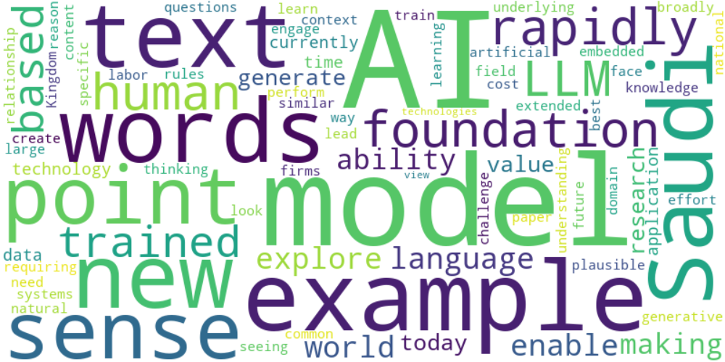

Top 10 words:

- AI: 13

- models: 8

- example: 6

- words: 5

- Saudi: 5

- text: 4

- point: 4

- sense: 4

- like: 4

- rapidly: 4

## Wordcloud for #fb5b89 Highlights

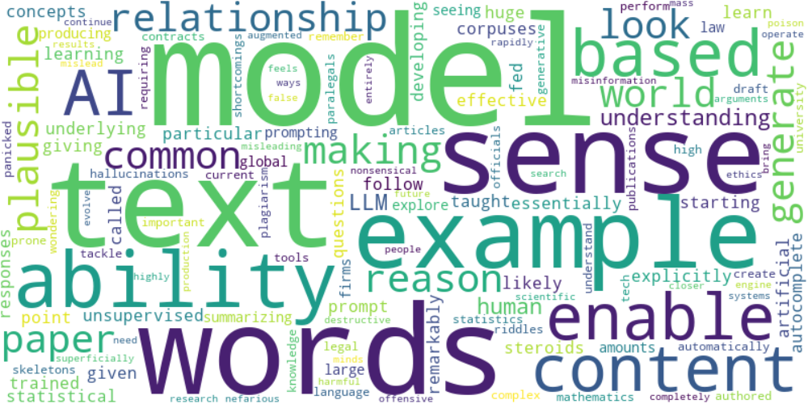

Top 10 words:

- models: 6

- words: 5

- text: 4

- sense: 4

- like: 3

- example: 3

- ability: 3

- model: 2

- content: 2

- based: 2

## Wordcloud for #c885da Highlights

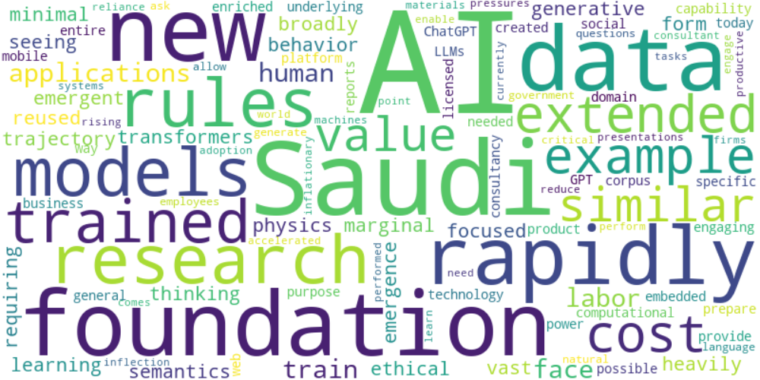

Top 10 words:

- AI: 9

- Saudi: 4

- new: 3

- rapidly: 3

- research: 2

- rules: 2

- foundation: 2

- trained: 2

- extended: 2

- example: 2